Lab name：**Integrator and Differentiator Circuits** Student ID： B11102112 Name: Chiajui Lee

# Purpose

Integrators and differentiators are fundamental electronic circuits with critical applications in electrical engineering. An integrator performs mathematical integration on input signals, while a differentiator calculates their time derivative. This experiment aims to:

1. **Understand** the core concepts and operating principles of these circuits
2. **Master** their design methodologies using operational amplifiers
3. **Explore** practical applications in analog signal processing

# Steps

1. Construct the circuit as specified in the problem using operational amplifiers (OPAs), capacitors, and resistors.
2. Connect the power supply to provide +10V to pin 8 and -10V to pin 4 of the operational amplifier (OPA).
3. Measure the output results using an oscilloscope.

# Data

## **Integrator Circuit**

* 1. Circuit diagram

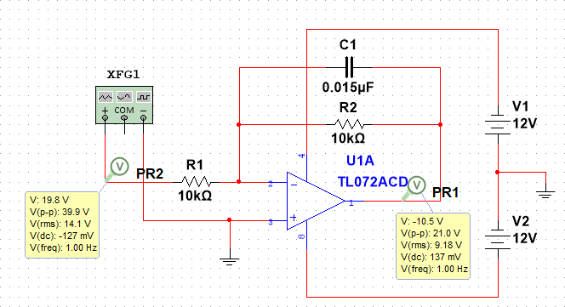

* 1. Output waveform
  2. 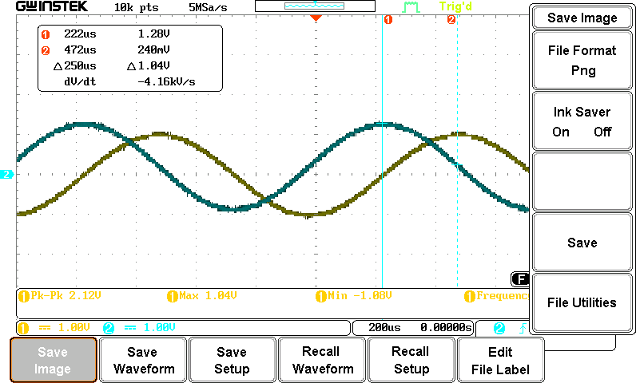Sin-wave
  3. Square-wave

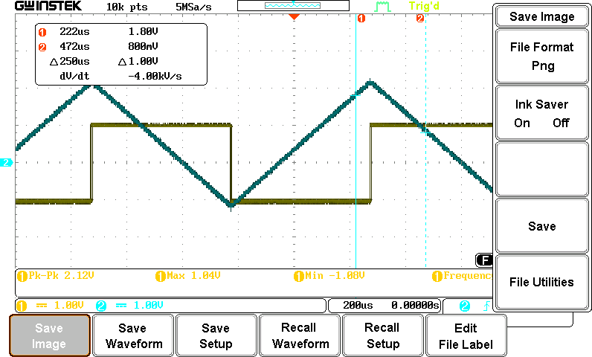

## **Astable Multivibrator Circuit**

1. Circuit diagram

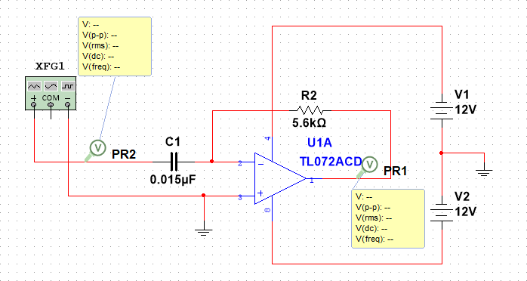

1. Output waveform
   1. Sin-wave

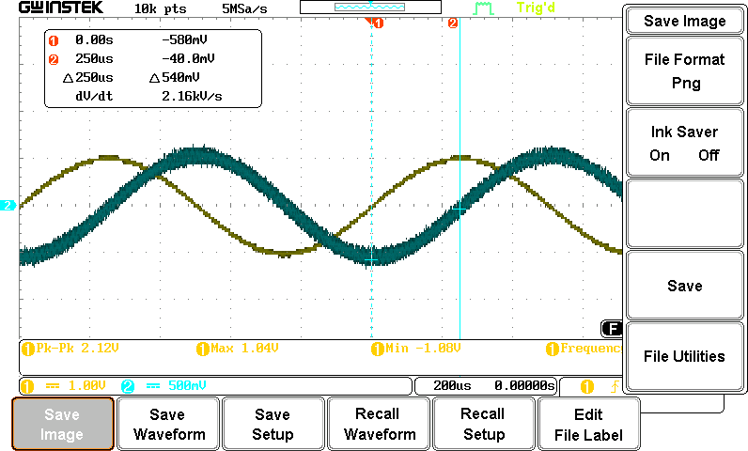

* 1. Square-wave

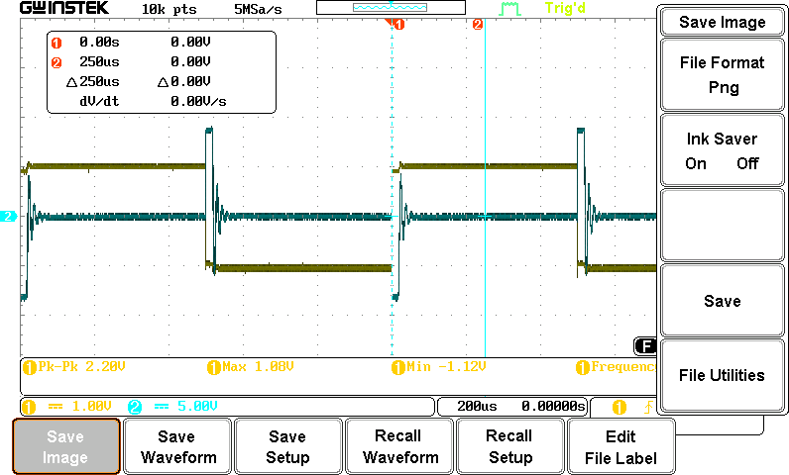

* 1. Triangle-wave

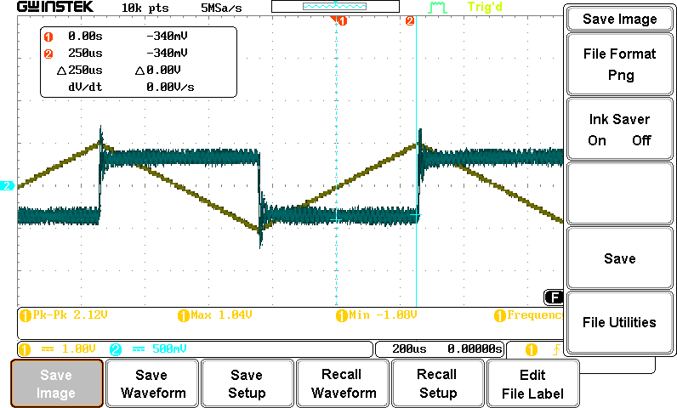

# Reflections

This practical session focused on revisiting integrator and differentiator circuits. Although we had recently studied these concepts in electronics theory classes, conducting actual experiments with them provided valuable hands-on experience.

The experiment was relatively straightforward due to the circuits' fundamental nature. We followed these steps:

1. Built both circuits according to the laboratory instructions
2. Used an oscilloscope to analyze the input-output waveform relationships:
   * The integrator transformed square waves into triangular waveforms
   * The differentiator converted square wave edges into sharp spikes

**Key Technical Observations**:

* Directly verified the mathematical operations (integration and differentiation) through waveform analysis
* Recognized their practical engineering applications in:
  + Active filter design
  + Signal processing systems
  + Feedback control mechanisms

The session effectively bridged theoretical knowledge with practical implementation, particularly regarding:

* Proper selection of RC time constants
* Addressing integrator drift issues
* Managing noise in differentiator circuits

**Educational Value**:  
The experiment successfully demonstrated how abstract mathematical operations translate into tangible electronic functions, while highlighting important design considerations for real-world applications.